Exercises Php

**Evaluated skills :**

*→ Php Variables*

*→ Conditions*

Question 1 :Fill in the blank :

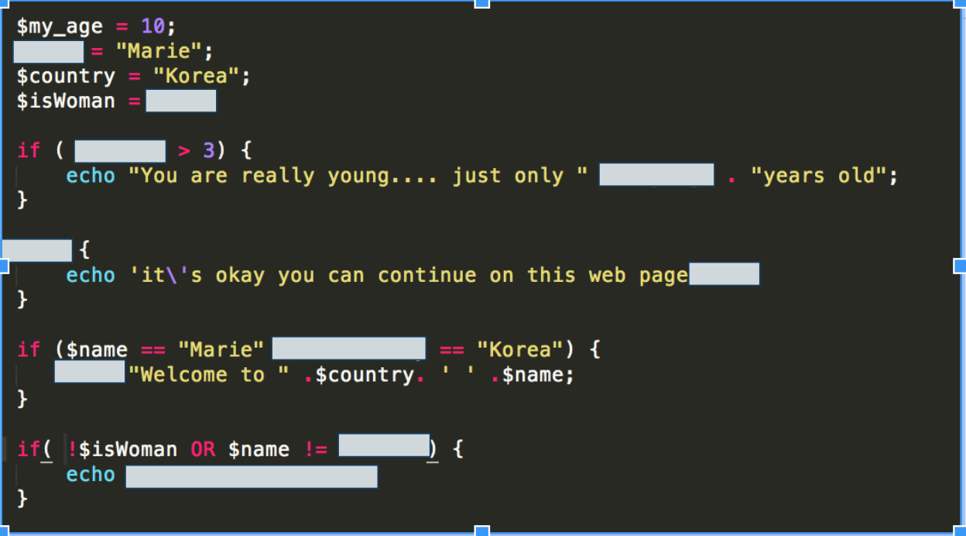

Question 2 : convert first this tab into a if/elseif/else condition then into a switch condition :

|  |  |
| --- | --- |
| Indice of pollution | |
| 0 | No pollution |
| 20 | No pollution |
| 50 | Little pollution |
| 90 | Little pollution → wear a mask |
| 110 | Medium pollution → wear a mask |
| 140 | Medium pollution → wear a mask |
| 180 | High pollution → wear a mask and no activities outside |
| 210 | Very High pollution → stay at home ! |
| 250 | Very high pollution → stay at home ! |
| default | no data entries - Do want you want ! |

Question 3 : convert into a ternary

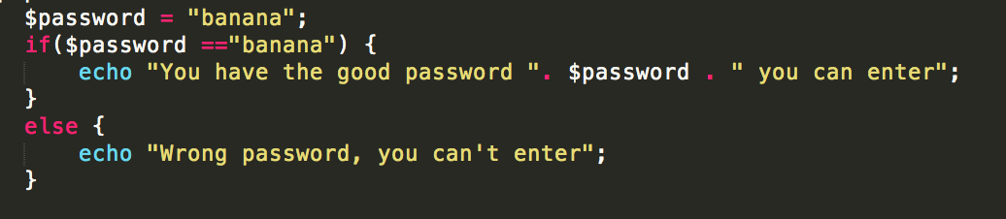

Question 4 : convert into a if/else condition :

